

BAPTIST CHURCH

April

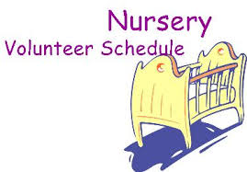
Apr 2………..……..Paula Knobloch, Mickey Stanford
Apr 9…………………….Shirley Marecle, Patti Radford
Apr 16………..………………Cissy Atwood, Becky Yount
Apr 23…Ashley Smothermon, Christine McManus
Apr 30…………………….Terri Edwards, Debby Dunkin
Jan 29…..Terri Edwards, Debby Dunkin

Weekly Service & Activity Schedule:

SUNDAY
Sunday School 9:45 a.m.
Morning Worship Services 11:00 a.m.
Evening Worship Services 6:00 p.m.

WEDNESDAY
Meal/Wednesday Bible Study. 6:30 p.m.

1662 CR 305

McDade, TX 78650

Phone: (512) 273-2743

Email: KnobbsSpringsBaptist@gmail.com



KnobbsSpringsBC.com

David Atwood – Pastor
(512) 470-5098

Patti Radford - Office Manager

KnobbsSpringsBaptist@gmail.com
512-273-2743
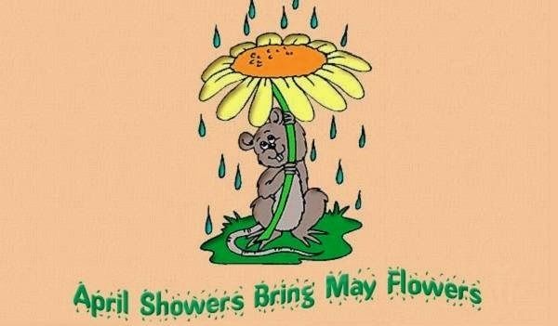

April Ushers
Mickey Stanford, Sam McManus,
David Condron, Jimmy Miller

April Hostesses/Hosts

Carolyn Breithaupt, Terri Edwards,

Sheila Waggoner, Earline Burns
WHAT’S GOING ON?


Corbit Fisher will be baptized Sunday April 2 after the worship service with a Pot Luck Lunch to follow in the Fellowship Hall


Community Wide Easter Egg Hunt Saturday April 15 9:00 am – 10:30 am

New Commandment Kids
Hands-on mission work thru puppet ministry and crafts to share with nursing homes, shut-ins, etc. Meeting the 1st and 2nd Sunday of each month @9:30 am
Ages Kinder thru 12th grade are welcome

April
2…………..……New Commandment Kids
2….Corbit Fisher Baptism/Pot Luck Lunch
9……….……….New Commandment Kids
9……..…Lord’s Supper/Business Meeting
13………………………..…Adult Fellowship
15……..Community Wide Easter Egg Hunt
16………….…..…..Easter Sunrise Service
20-22……………….……Directory Pictures
27…………………………Adult Fellowship

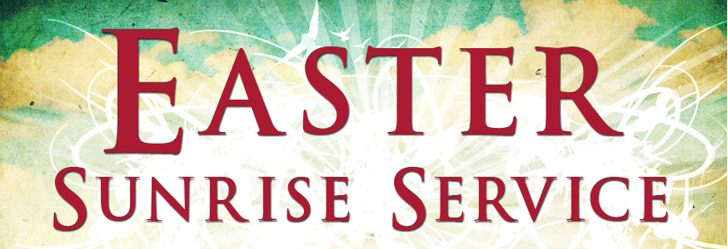

Easter Sunday April 16 @ 7:00 am on the lawn in the front of the church

Life Touch will hold photography sessions on the following dates and times:

April 20 – 2:00pm – 8:10pm
April 21 – 12:30pm – 6:40pm
April 22 – 9:30am – 4:10pm

Contact Brenda Williams for questions 512-925-8572



The month of April begins with “April Fool’s Day”. The practice of playing jokes on people has been going on for hundreds of years, and I’m not sure how April 1st became dedicated as THE day to do this. No one likes to be called a fool; the dictionary defines the word “fool” as: “One who is deficient in judgement, sense, or understanding; one who acts unwisely on a given occasion”.
To me, the most telling use of that word is recorded in Psalm 14:1; “The fool has said in his heart, “There is no God”. There are millions of people in this world who believe there is no God. How sad and how foolish it is to see and experience the beauty of spring and all the blessings of this life, and to not acknowledge the presence of God. And sadder yet, is the fate that these people will experience some day because of their rejection of Almighty God, if their hearts are not changed.
Our job as Christians is to show and tell the world, through our lives and our words, that there IS a God of love, grace, and mercy that leads us, blesses us, and is the source of everything that makes life worth living.
The month of April for Knobbs Springs begins with two ordinances that define us as Christians. We will be witnesses of the baptism of a new believer, Corbit Fisher, on April 2nd, and then on April 9th, we observe The Lord’s Supper. What a wonderful way to begin this month.
The calendar is filled with activities this month, and I pray that you will be a part of as many of these activities as you can. The “fellowship of believers” means to gather together as a body of believers, to celebrate the fact that there IS a loving God, and to be an active part of this fellowship.
God bless you all,
David L. Atwood

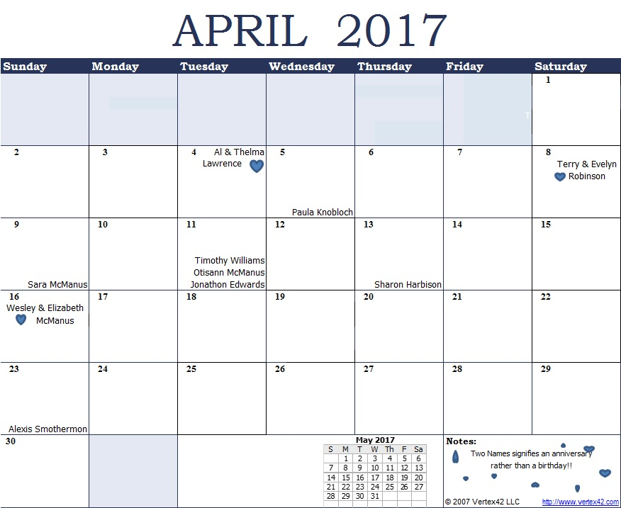
K s b c
Keeping His Word through Sunday School, Bible Study and Church Attendance/Worship
Sunday School Bible Studies for April :
Apr 2nd Victory Over Fear Romans 8:31-39 Apr 9th Victory Shared Luke 24:44-49 Apr 16th He Is Risen Luke 24:1-8; 36-40
Apr 23rd Life In Christ Luke 9:18-26 Apr 30th Life In Church 1 Peter 4:7-11
9:45 a.m. each Sunday – A place for everyone
WE’D LOVE FOR YOU TO JOIN US!

